**Software Testing Assignment**

**Module–1(Fundamental)**

• What is SDLC?

* SDLC is a structure imposed on the development of a software product that defines the process for planning, implementation, testing, documentation, deployment, and ongoing maintenance and support. There are a number of different development models.
* A Software Development Life Cycle is essentially a series of steps, or phases, that provide a model for the development and lifecycle management of an application or piece of software.

• What is software testing?

* Software Testing is a process used to identify the correctness, completeness, and quality of developed computer software.

• What is agile methodology?

* Agile SDLC model is a combination of iterative and incremental process models with focus on process adaptability and customer satisfaction by rapid delivery of working software product.

• What is SRS

* A software requirements specification (SRS) is a complete description of the behavior of the system to be developed.
* It includes a set of use cases that describe all of the interactions that the users will have with the software.

• What is oops

* OOPS stands for Object-Oriented Programming System.
* Programming languages used to developed software are based on OOPS.

• Write Basic Concepts of oops

* Class
* Object
* Inheritance
* Polymorphism
* Abstraction
* Encapsulation

• What is object

* Object is instance of class OR we can say that object is real world entity.

• What is class

* Class is structure in which member functions and member variables are there.

• What is encapsulation

* To wrapping up data into single unit is called encapsulation.

• What is inheritance

* To access property of one class to another class is call inheritance.

• What is polymorphism

* Having same function name but with different functionalities is called polymorphism.

• Draw Use case on Online book shopping

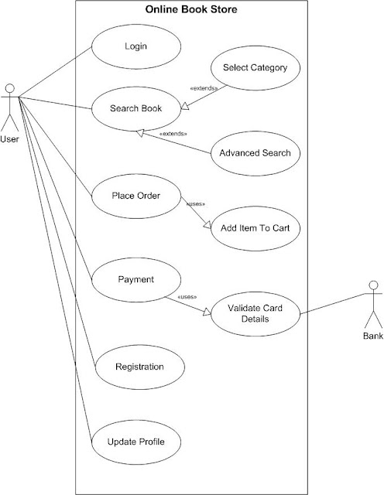

• Draw Use case on online bill payment system (paytm)

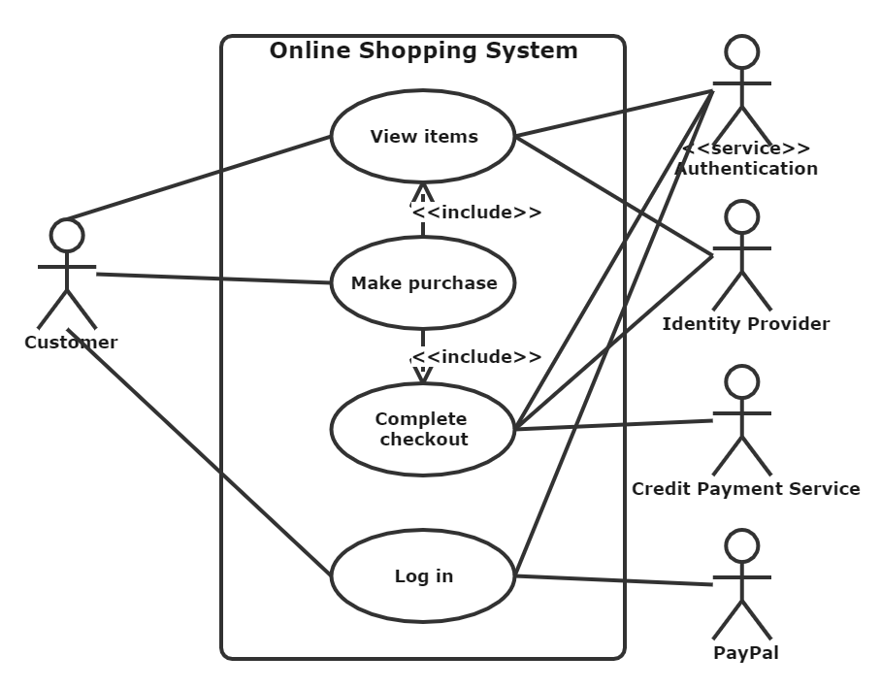

• Write SDLC phases with basic introduction

* Requirement Gathering

Features

Usage scenarios

Although requirements may be documented in written form, they may be incomplete, unambiguous, or even incorrect.

Requirements will Change!

Inadequately captured or expressed in the first place

User and business needs change during the project

Validation is needed throughout the software lifecycle, not only when the “final system” is delivered.

Build constant feedback into the project plan

Plan for change

Early prototyping [e.g., UI] can help clarify the requirements Functional and Non-Functional

* Analysis Phase

The analysis phase defines the requirements of the system, independent of how these requirements will be accomplished. This phase defines the problem that the customer is trying to solve.

* Design Phase

The Design team can now expand upon the information established in the requirement document. The requirement document must guide this decision process. Analyzing the trade-offs of necessary complexity allows for many things to remain simple which, in turn, will eventually lead to a higher quality product.

* Implementation Phase

In the implementation phase, the team builds the components either from scratch or by composition. Given the architecture document from the design phase and the requirement document from the analysis phase, the team should build exactly what has been requested, though there is still room for innovation and flexibility

* Testing Phase

Simply stated, quality is very important. Many companies have not learned that quality is important and deliver more claimed functionality but at a lower quality level. It is much easier to explain to a customer why there is a missing feature than to explain to a customer why the product lacks quality. A customer satisfied with the quality of a product will remain loyal and wait for new functionality in the next version. Quality is a distinguishing attribute of a system indicating the degree of excellence.

* Maintenance Phase

Software maintenance is one of the activities in software engineering, and is the process of enhancing and optimizing deployed software (software release), as well as fixing defects. Software maintenance is also one of the phases in the System Development Life Cycle (SDLC), as it applies to software development. The maintenance phase is the phase which comes after deployment of the software into the field.

• Explain Phases of the waterfall model

* **Requirement Gathering and analysis** − All possible requirements of the system to be developed are captured in this phase and documented in a requirement specification document.
* **System Design** − The requirement specifications from first phase are studied in this phase and the system design is prepared. This system design helps in specifying hardware and system requirements and helps in defining the overall system architecture.
* **Implementation** − With inputs from the system design, the system is first developed in small programs called units, which are integrated in the next phase. Each unit is developed and tested for its functionality, which is referred to as Unit Testing.
* **Integration and Testing** − All the units developed in the implementation phase are integrated into a system after testing of each unit. Post integration the entire system is tested for any faults and failures.
* **Deployment of system** − Once the functional and non-functional testing is done; the product is deployed in the customer environment or released into the market.
* **Maintenance** − There are some issues which come up in the client environment. To fix those issues, patches are released. Also to enhance the product some better versions are released. Maintenance is done to deliver these changes in the customer environment.

• Write phases of spiral model

* **Determine objectives and find alternate solutions**

**Risk Analysis and resolving**

**Develop and test**

**Review and planning of the next phase**

• Write agile manifesto principles

* individuals and interactions over processes and tools;

working software over comprehensive documentation;

customer collaboration over contract negotiation; and

responding to change over following a plan.

• Explain working methodology of agile model and also write pros and cons.

* Agile SDLC model is a combination of iterative and incremental process models with focus on process adaptability and customer satisfaction by rapid delivery of working software product.
* Agile Methods break the product into small incremental builds.
* These builds are provided in iterations.
* Each iteration typically lasts from about one to three weeks.
* Every iteration involves cross functional teams working simultaneously on various areas like planning, requirements analysis, design, coding, unit testing, and acceptance testing.
* At the end of the iteration a working product is displayed to the customer and important stakeholders.

**PROS**

* Is a very realistic approach to software development
* Promotes teamwork and cross training.
* Functionality can be developed rapidly and demonstrated.
* Resource requirements are minimum.
* Suitable for fixed or changing requirements
* Delivers early partial working solutions.
* Good model for environments that change steadily.
* Minimal rules, documentation easily employed.
* Enables concurrent development and delivery within an overall planned context.
* Little or no planning required
* Easy to manage
* Gives flexibility to developers

**CONS**

* Not suitable for handling complex dependencies.
* More risk of sustainability, maintainability and extensibility.
* An overall plan, an agile leader and agile PM practice is a must without which it will not work.
* Strict delivery management dictates the scope, functionality to be delivered, and adjustments to meet the deadlines.
* Depends heavily on customer interaction, so if customer is not clear, team can be driven in the wrong direction.
* There is very high individual dependency, since there is minimum documentation generated.
* Transfer of technology to new team members may be quite challenging due to lack of documentation.

• Draw usecase on Online shopping product using COD.

• Draw usecase on Online shopping product using payment gateway.

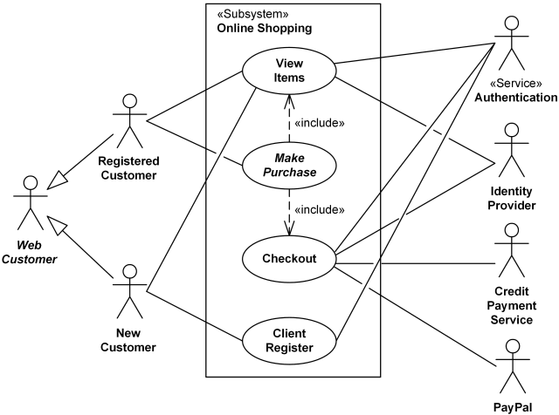

**Module–2(Manual Testing)**

• What is Exploratory Testing?

* **Exploratory Testing** is a type of software testing where Test cases are not created in advance but testers check system on the fly. They may note down ideas about what to test before test execution. The focus of exploratory testing is more on testing as a “thinking” activity.

Exploratory Testing is widely used in Agile models and is all about discovery, investigation, and learning. It emphasizes personal freedom and responsibility of the individual tester.

• What is traceability matrix?

• What is Boundary value testing?

• What is Equivalence partitioning testing?

• What is Integration testing?

• What determines the level of risk?

• What is Alpha testing?

• What is beta testing?

• What is component testing?

• What is functional system testing?

• What is Non-Functional Testing?

• What is GUI Testing?

• What is Adhoc testing?

• What is load testing?

• What is stress Testing?

• What is white box testing and list the types of white box testing?

• What is black box testing? What are the different black box testing techniques?

• Mention what are the categories of defects?

• Mention what bigbang testing is?

• What is the purpose of exit criteria?

• When should "Regression Testing" be performed?

• What is 7 key principles? Explain in detail?

• Difference between QA v/s QC v/s Tester

• Difference between Smoke and Sanity?

• Difference between verification and Validation

• Explain types of Performance testing.

• What is Error, Defect, Bug and failure?

• Difference between Priority and Severity

• What is Bug Life Cycle?

• Explain the difference between Functional testing and NonFunctional testing

• To create HLR & TestCase of 1)(Instagram , Facebook) only first page 2) Facebook Login Page : <https://www.facebook.com/>

• What is the difference between the STLC (Software Testing Life Cycle) and SDLC (Software Development Life Cycle)?

• What is the difference between test scenarios, test cases, and test script?

• Explain what Test Plan is? What is the information that should be covered.

• What is priority?

• What is severity?

• Bug categories are…

• Advantage of Bugzila .

• Difference between priority and severity

• What are the different Methodologies in Agile Development Model?

• Explain the difference between Authorization and Authentication in Web testing.What are the common problems faced in Web testing? To create HLR & TestCase of WebBased (WhatsApp web , Instagram) 1. WhatsApp Web : <https://web.whatsapp.com/>

• To create HLR and TestCase on this Link. <https://artoftesting.com/>

• Write a scenario of only Whatsapp chat messages

• Write a Scenario of Pen

• Write a Scenario of Pen Stand

• Write a Scenario of Door

• Write a Scenario of ATM

• When to used Usablity Testing?

• What is the procedure for GUI Testing?

• Write a scenario of Microwave Owen

• Write a scenario of Coffee vending Machine

• Write a scenario of chair

• To Create Scenario (Positive & Negative) 2. facebook Chat on Mobile 3. Online shopping to buy product (flipkart)

• Write a Scenario of Wrist Watch

• Write a Scenario of Lift(Elevator)

• Write a Scenario of whatsapp Group (generate group)

• Write a Scenario of instagram ( video call with chat )

• Write a Scenario of Whatsapp payment Module 3 (Testing on Live Application)

• What is RDBMS

• What is SQL

• Write SQL Commands

• What is join?

• Write type of joins.

• How Many constraint and describes it self

• Difference between RDBMS vs DBMS

• What is API Testing

• Types of API Testing

• What is Responsive Testing?

• Which types of tools are available for Responsive Testing

• What is the full form of .ipa, .apk

• How to create step for to open the developer option mode ON?

• To check Module-4 Automation Core Testing (Load Runner Up and Selenium IDE)

• Which components have you used in Load Runner?

• How can you set the number of Vusers in Load Runner?

• What is Correlation?

• What is the process for developing a Vuser Script?

• How Load Runner interacts with the application?

• How many VUsers are required for load testing?

• What is the relationship between Response Time and Throughput?

• What is the difference between hits/second and requests/second?

• To test the Performance testing on “Tops Technologies website” :- https://www.topsint.com/ 1. to Record all top level menu 2. to Record minimum 10 Vuser on this website 3. save all (Script,Design,Graph)

• create a normal script of above website with correlate using hp default website. Selenium IDE)

• What is Automation Testing?

• Which Are The Browsers Supported By Selenium Ide?

• What are the benefits of Automation Testing?

• What are the advantages of Selenium?

• Why testers should opt for Selenium and not QTP?

• To validate the tops technologies website Contact us page and enter your friend detail at last “Guest Call Back” <https://www.tops-int.com/contact-us/>

• To validate the tops technologies website Contact us page and enter your friend detail at last “Guest Call Back” https://www.tops-int.com/contact-us/ 1. To use assert 2. To use click and wait 3. To use locators 4. To use other command